Project Development Phase Model Performance Test

Date | 25-06-2026
Team ID | 23A51A0215
Project Name | Metro Ticket Generating System in ServiceNow
Maximum Marks | 10 Marks

Model Performance Testing:
Project team shall fill the following information in model performance testing template.

S.No. | Parameter | Values | Screenshot
1. | System Summary | Metro Ticket Booking System developed on ServiceNow. Users can select source and destination stations, choose journey details, calculate fares automatically, generate digital tickets, and receive booking confirmations through notifications. | 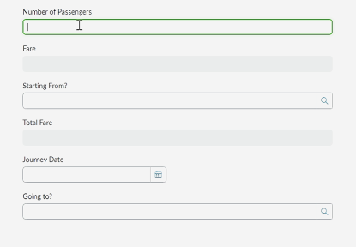
2. | Functional Accuracy | Fare Calculation Accuracy – 100% Ticket Generation Accuracy – 100%  Notification Delivery Accuracy – 95% | 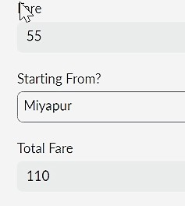
3. | Performance Testing | Average Fare Calculation Time – Less than 2 seconds  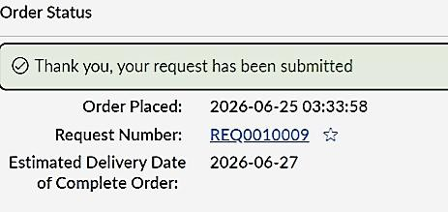  Average Ticket Generation Time – Less than 3 seconds  Dashboard Loading Time – Less than 5 seconds

4. | User Acceptance Testing | Users successfully completed ticket booking, fare calculation, ticket generation, and notification receipt without critical issues. | 